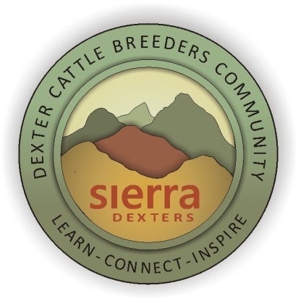
Sierra Dexter Cattle Breeders
and Small Farm Community
St. Patrick’s Day
Kick-Off Event
March 17th 10am – 5pm
Cattle & Livestock Workshops
Farm Skills Demonstrations
Potluck Lunch & Raffle
In the barn @
7101 34th Street
North Highlands, CA

“Kick-Off” Event Schedule
10am
Bob Curlee – Introductions
Laura Christofk – President of The Purebred Dexter Cattle Association. Inspired by Ohio and Utah Dexter breeder groups and how we can improving the Dexter market with increased public awareness in our region.
Rex Williams – promoting youth and Dexters
10:30 Mike Lewis, AI Technician - Tips For Successful Artificial Insemination
11am - Cindy Morgan, Vet Technician – DIY cattle fecal testing for parasites
Description: All animals carry parasites. No big deal, until the parasite load becomes more than your animals can handle. But before the symptoms are visible in your animals condition, why not do a quick DIY test? Cindy will demonstrate how and what to look for under the microscope. So… Bring some shit and DIY.
12pm - Putluck Lunch
1pm - Jenine Windeshausen - 30 minute Felting
Description: This is NOT about your typical fuzzy sheet of crafting material. Jenine will give a quick basic felting demo, then will amaze and inspire you with samples of garments and artwork that she has created by artistically blending silks, lace, shells and other materials into naturally dyed wool fibers. Beyond being durable and useful, her unique felting creations are beautifully earthy or organic and even a bit exotic.
2pm – Samantha Lane – 30 minute Tallow Soap
Description: Do not throw that fat away! Samantha will give a basic cold-process soap making demo using Dexter tallow (fat). Tallow soap is nourishing and gentle to your skin, easy to make, rewarding to use personally, and makes great “from the farm” gifts.
Samantha sells her handmade soaps online @ Lane Ranch Sundries
www.etsy.com/shop/laneranch sundries
3pm – Carolyn Fox – “Optimizing Your Pasture for Your Individual Needs”
Description: “Hands on” material and instruction to help you learn not only about, but ideas HOW to optimize the shrubs, grasses, forage herbs, weeds and flowers that naturalize naturally in your area; from your livestock, to your poultry, fruit trees, garden and even your dinner plate! Be inspired by Master Herbalist Carolynn Fox, to think “outside of the box!”

4pm – Tom Wade – Healthy Pasture Soil: Managing the Herd Below Your Feet
Description: Tom Wade of Bluebird Farm, an educational farm just outside of Nevada City, is a well know teacher/speaker on Permaculture and Soil Biology and is an outright “soil geek.” His knowledge, insights, passion and enthusiasm about the miraculous world that exists beneath our cows feet will inspire you and allow you to see your pasture in an entirely new way. Tom and his wife Renee were once Dexter owners (they have downsized to goats) so this info will be 100% on target for creating better soil for better pastures. Learn more Tom, Renee and Bluebird Farm @ https://gardenwithnature.wordpress.com/bluebird-farm/

5pm – Raffle (must be present to win)

About Us
We are Dexter cattle breeders and small farmers located in the states of the Western Sierras interested in learning, sharing and connecting with like minded folks.
Owning Dexter cattle not required.
Our goal is to learn, connect, inspire and have fun with a focus on better cattle & livestock management, better breeding, better pastures, better soil, and better farm management.
​Our Organizer
Bob Curlee - Crest Point Farms, Grass Valley, CA
(650)776-8840
Website www.dexterstoday.com/sierra-dexters
Email sierradexters@gmail.com
About this Event
This is our first “official” event so it’s gonna be great! Our speakers and the topics are amazing, original and a bit “outside the box” in a good way. They will not disappoint!
Rather than fret about the possibility of wet weather ruining our plans… we are just planning on rainy, wet weather and having this “gathering” indoors. So plan for indoor sunshine, no clouds and a breath of fresh air.
Location
In the barn @ 7101 34th Street North Highlands, CA
Future Events
We plan to have “gatherings” quarterly:
Winter Workshops (which is what this event is all about), indoor workshops
Spring Fling – May/June: Live cattle & livestock demonstrations
Summer – Field trips/Farm Tours
Fall - ? maybe a Show and Sale? TBD
Join Us
Just go to our website and add your name to the Sierra Dexters contact list for updates and future gatherings – That’s it!
We will have other resources available for you on our website as well – We are a work in progress.

